**MANUSCRIPT TITLE**

**(Not more than 25 words, Font: Capital, Time New Roman, 15, Bold, Align Text Centered)**

Author’s name 11*, Author’s name 22 (Times New Roman, 12, Align Text Centered)

*1Author 1’s affiliation 1 (Times New Roman, 11, italics, Align Text Right)*

*2 Author 2’s affiliation 2 (Times New Roman, 11, italics, Align Text Right)*

*Corresponding author: (*the 1st Author*, email)*

|  |  |
| --- | --- |
| **GENERAL INFORMATION** | **ABSTRACT** |
| Received date: | The abstract should be no more than 300 words in length. The abstract is presented briefly including: the purpose of the study, the methods, the main results and the conclusions. The abstract may not contain any unannotated abbreviations. If so, the abbreviations must be repeated at least twice so that they are noted from the first time mentioned in the abstract. References are not cited in the Abstract. |
| Revised date: |
| Accepted date: |
| **KEYWORD** |
| *Keyword 1;*  *Keyword 2;*  Maximum 05 keywords, each keyword is separated by a semicolon, italicized, arranged in alphabetical order. |

**1. INTRODUCTION**

Articles published in Dong Nai Technology University Journal of Science and Technology are written in Vietnamese or English on paper size 210 mm x 270 mm, font Times new Roman (Unicode), font size 12; top margin: 1.7cm; Bottom: 1.5cm, left 2.5cm, right 2cm. Paragraph – spacing - before and after: 6pt, line spacing: single. The content of the article is divided into 2 columns.

The contents are presented in this section such as: background, research context, importance of the research, literature review, identification of research problems, indication of the research’s novelty, and research objectives; avoiding lengthy, detailed presentations or just listing and summarizing previous studies.

**2. METHODOLOGY**

The methodology is described in full details so that other researchers can apply it. Specific contents include: research design, research object, research location and time, sample size and sampling, research tools and techniques of information collection, data analysis, etc. Published methods should be cited and described if modified.

**3. FINDINGS AND DISCUSSION**

The results/findings of the research are presented in this section, to answer the research questions; the important results should be presented in a logical order; interpret briefly, clearly, coherently, not simply repeat the data in the table/figure, especially truthful with the results. Discussions, explanations, comparisons with the results of previous studies are also presented. Limitations of the study are stated if any.

**3.1. How to write bullet points**

The manuscript has no more than two levels of bullet points. How to write the bullet points is illustrated as follows:

**1. INTRODUCTION**

**1.1. Background....**

***1.1.1. Context....***

**3.2. Figure and table**

Figures are presented clearly, with high resolution. Figures are numbered in order, for example: Figure 1, Figure 2,... The figure’s name is below the figure, centered. If there is a citation, the source must be cited.

The title of the table is above the table and numbered in sequence, for example: Table 1, Table 2,... Similar to the regulations as shown in the figure, if there is a citation, the source must be cited.

Illustrated as the figure and table below:

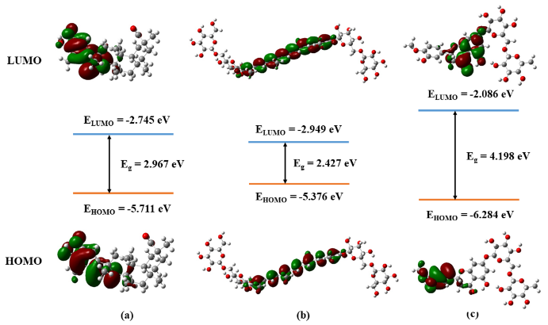

**Figure 1.** Figure’s name (Time New Roman, Align Text Centered**,** Font size: 11)

**Table 1.** Table’s name (Time New Roman, Align Text Centered**,** Font size: 11)

|  |  |
| --- | --- |
| **Thông số** | **Giá trị** |
| Electronegativity, χ (eV) | 4,163 |
| Electrophilicity, ω (eV) | 7,140 |

**3.3. Formula**

Use the MathType tool (http://www.mathtype.com) to present the formulas in the paper. Formulas must be numbered consecutively from the beginning to the end of the article, the number of the formula is enclosed in parentheses near the right margin of the column. The formula can be written as shown below:

|  |  |
| --- | --- |
|  | (1) |
|  | (2) |
|  | (3) |
|  | (4) |

**3.4. Scientific names**

Scientific names are italicized, write the full word in the first writing, then it is necessary to consistently use abbreviations throughout the article, for example: write the full name *Escherichia coli* at the first time, *E. coli* from the second written time.

**3.5. Abbreviations**

An abbreviation is used when it is repeated at least twice in the article. Abbreviations should be introduced at the first appearance, then used consistently throughout the manuscript.

**3.6. Units of measurement**

Units of measurement are written with one space (e.g., 5 mL, 5 kg) except percentage and temperature (e.g., 10%, 100°C).

**4. CONCLUSION**

The conclusion must be clear and concise on the basis of the results of the research; state the meanings of the study, propose further research directions; do not repeat the study results.

**SUPPLEMENTARY INFORMATION**

Supplementary Information (SI) is attached to the manuscript and submitted to the journal including tables out of specification, figures, formulas, details of experimental methods, etc. SI saved as a .pdf file and numbered the pages.

**ACKNOWLEDGEMENT (IF YES)**

In this section, the authors can thank the agencies and organizations that helped the authors in the implementation of the research. It could be the place of funding, the laboratory, the materials, the research facilities, or the person helping to read and comment on the paper.

**REFERENCES**

All references and citations must follow the APA (American Psychological Association) format

**TÊN BÀI BÁO**

**(Tối đa 25 từ, kiểu chữ: Capital, Time New Roman, 15, Bold, Align Text Centered)**

Học hàm/học vị Tên tác giả 11*, Học hàm/học vị Tên tác giả 22 (Times New Roman, 12, Align Text Centered)

*1Đơn vị công tác Tác giả 1 (Times New Roman, 11, italics, Align Text Right)*

*2Đơn vị công tác Tác giả 2 (Times New Roman, 11, italics, Align Text Right)*

*Tác giả liên hệ: (*Tên* *tác giả đầu có sao, email)*

|  |  |
| --- | --- |
| **THÔNG TIN CHUNG** | **TÓM TẮT** |
| Ngày nhận bài: | Tóm tắt nên có độ dài không quá 300 từ. Tóm tắt được trình bày ngắn gọn bao gồm: mục đích của nghiên cứu, phương pháp được sử dụng, kết quả chính và kết luận chính. Tóm tắt không được chứa bất kỳ chữ viết tắt nào không ghi chú. Nếu có thì các từ viết tắt đó phải lập lại ít nhất hai lần thì chúng được ghi chú ngay từ lần đầu tiên được đề cập trong phần tóm tắt. Tài liệu tham khảo không được trích dẫn trong phần Tóm tắt. |
| Ngày nhận bài sửa: |
| Ngày duyệt đăng: |
| **TỪ KHOÁ** |
| *Từ khoá 1;*  *Từ khoá 2;*  Tối đa 05 từ khóa, mỗi từ khóa cách nhau bằng dấu chấm phẩy, in nghiêng, xếp theo thứ tự bảng chữ cái. |